What if I make a mistake? I feel uncertain. What should I do?
Information over experimentation
This is when a person asks many questions to gain certainty before trying something new. These questions often concern "what if" situations when something goes wrong. Information over experimentation is a fixed mindset symptom where the person tries to reduce the risk of failure.
Key principle
It is impossible to reduce the risk of mistakes to zero. This leads people to ask so many questions that they never practice. Because they can never reach certainty, they can get frustrated and even blame others for not giving them the certainty they want.
Theory-practice cycle
One of the most critical concepts for learning new skills is engaging in the theory-practice cycle as early and frequently as possible.
This can be different to what we think learning a new skill involves. Many people place high importance on understanding the theory and technique, while practice is to gain fluency and mastery (i.e. "to get used to it")
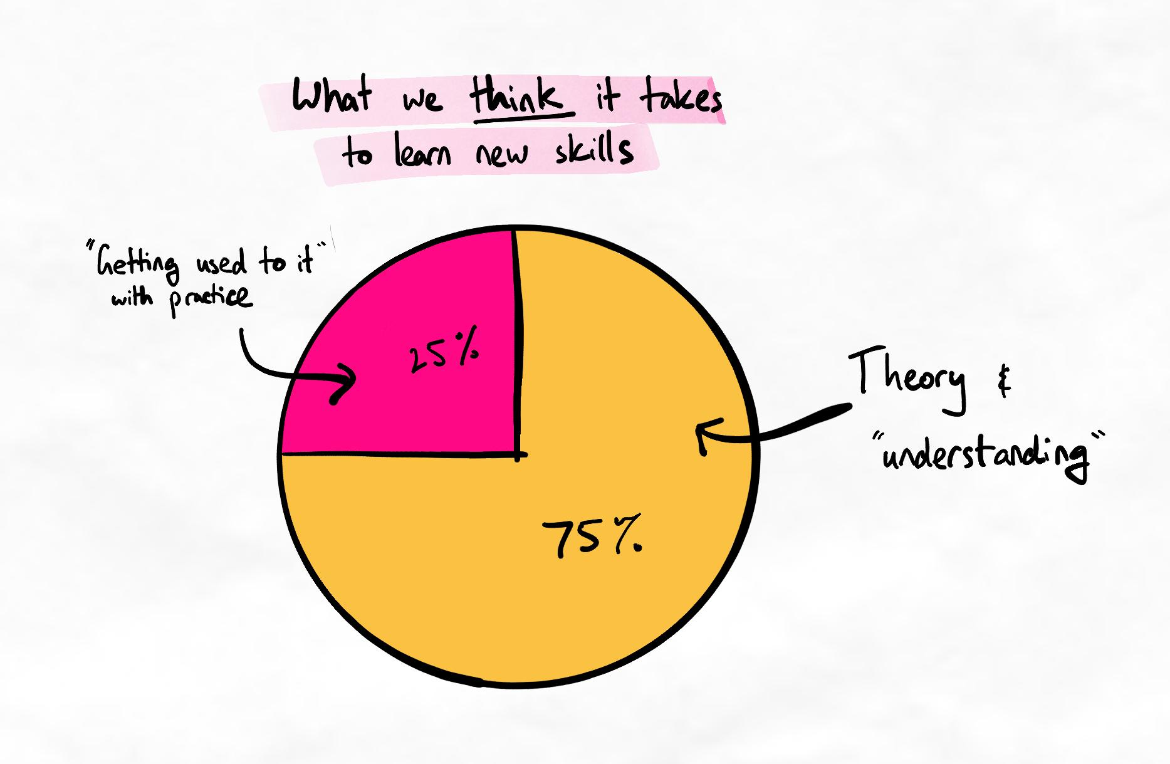
However, in reality, practice is necessary to understand the theory more deeply and correct misconceptions. Because complex skills can have many different aspects to learn, practice gives us relevance and a clear idea of which parts of the theory to focus on.
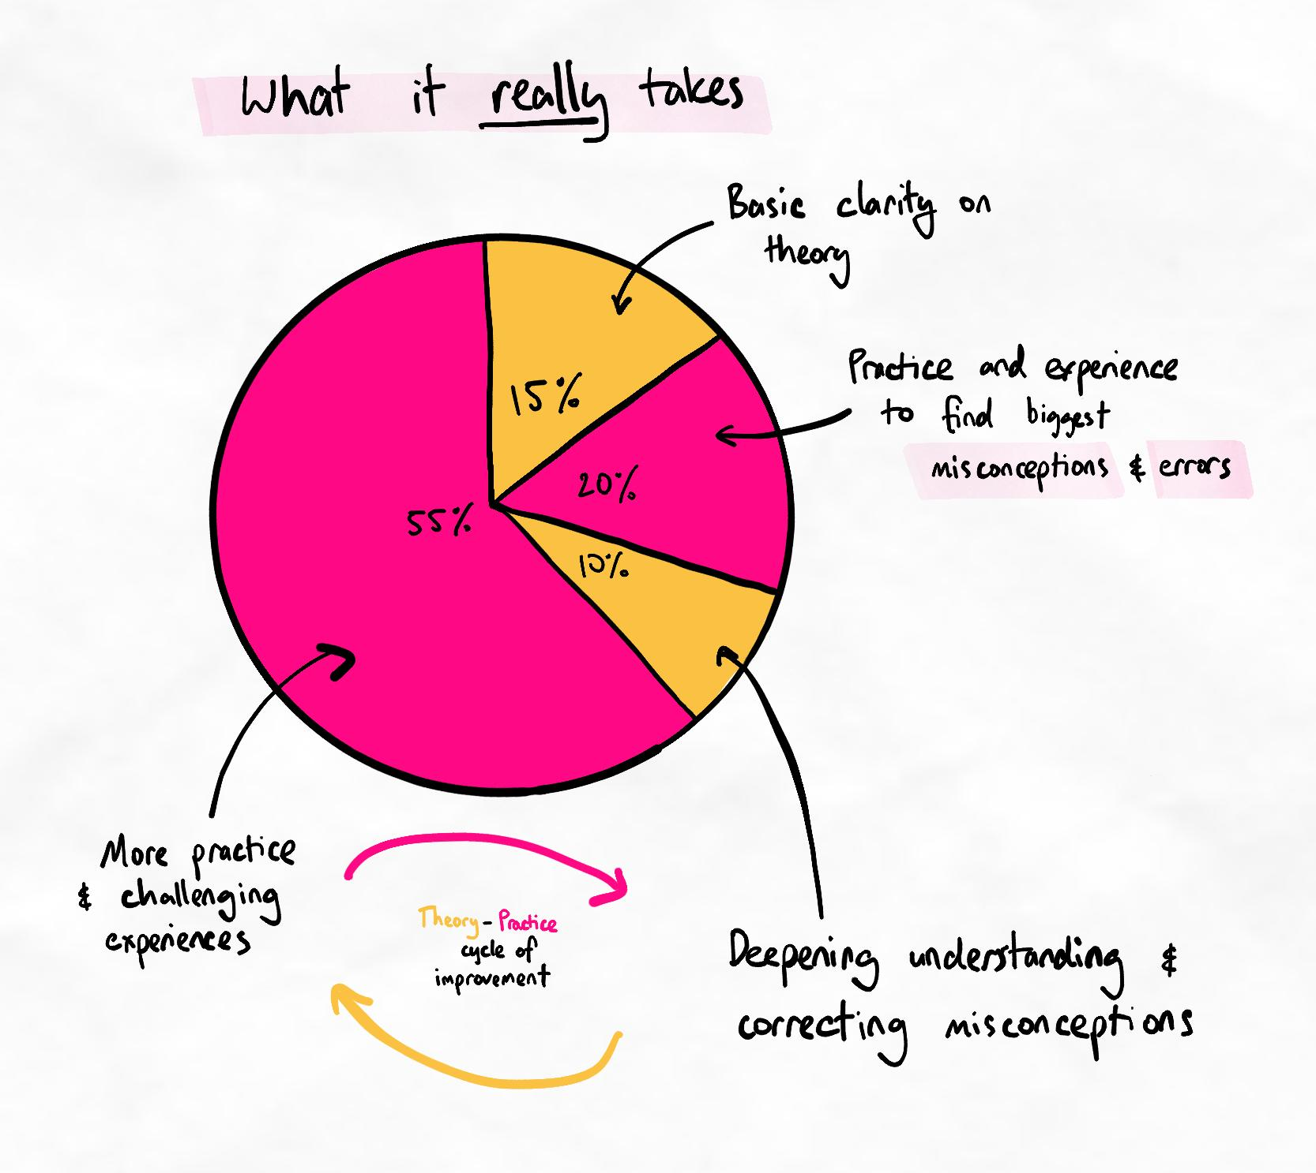
The inverse-U value of information
Asking too many questions before attempting something is detrimental. The graph below shows that:
- When you have too little information about something, the chance of success is low. This is because there are too many unknowns around how to do the process correctly.
- When you have the appropriate amount of information, the chance of success is high. This is because there is relative clarity on the process.
- When you have too much information, the chances of success are low again. This is because there are now too many things you have to consider while attempting the process. This creates overload.
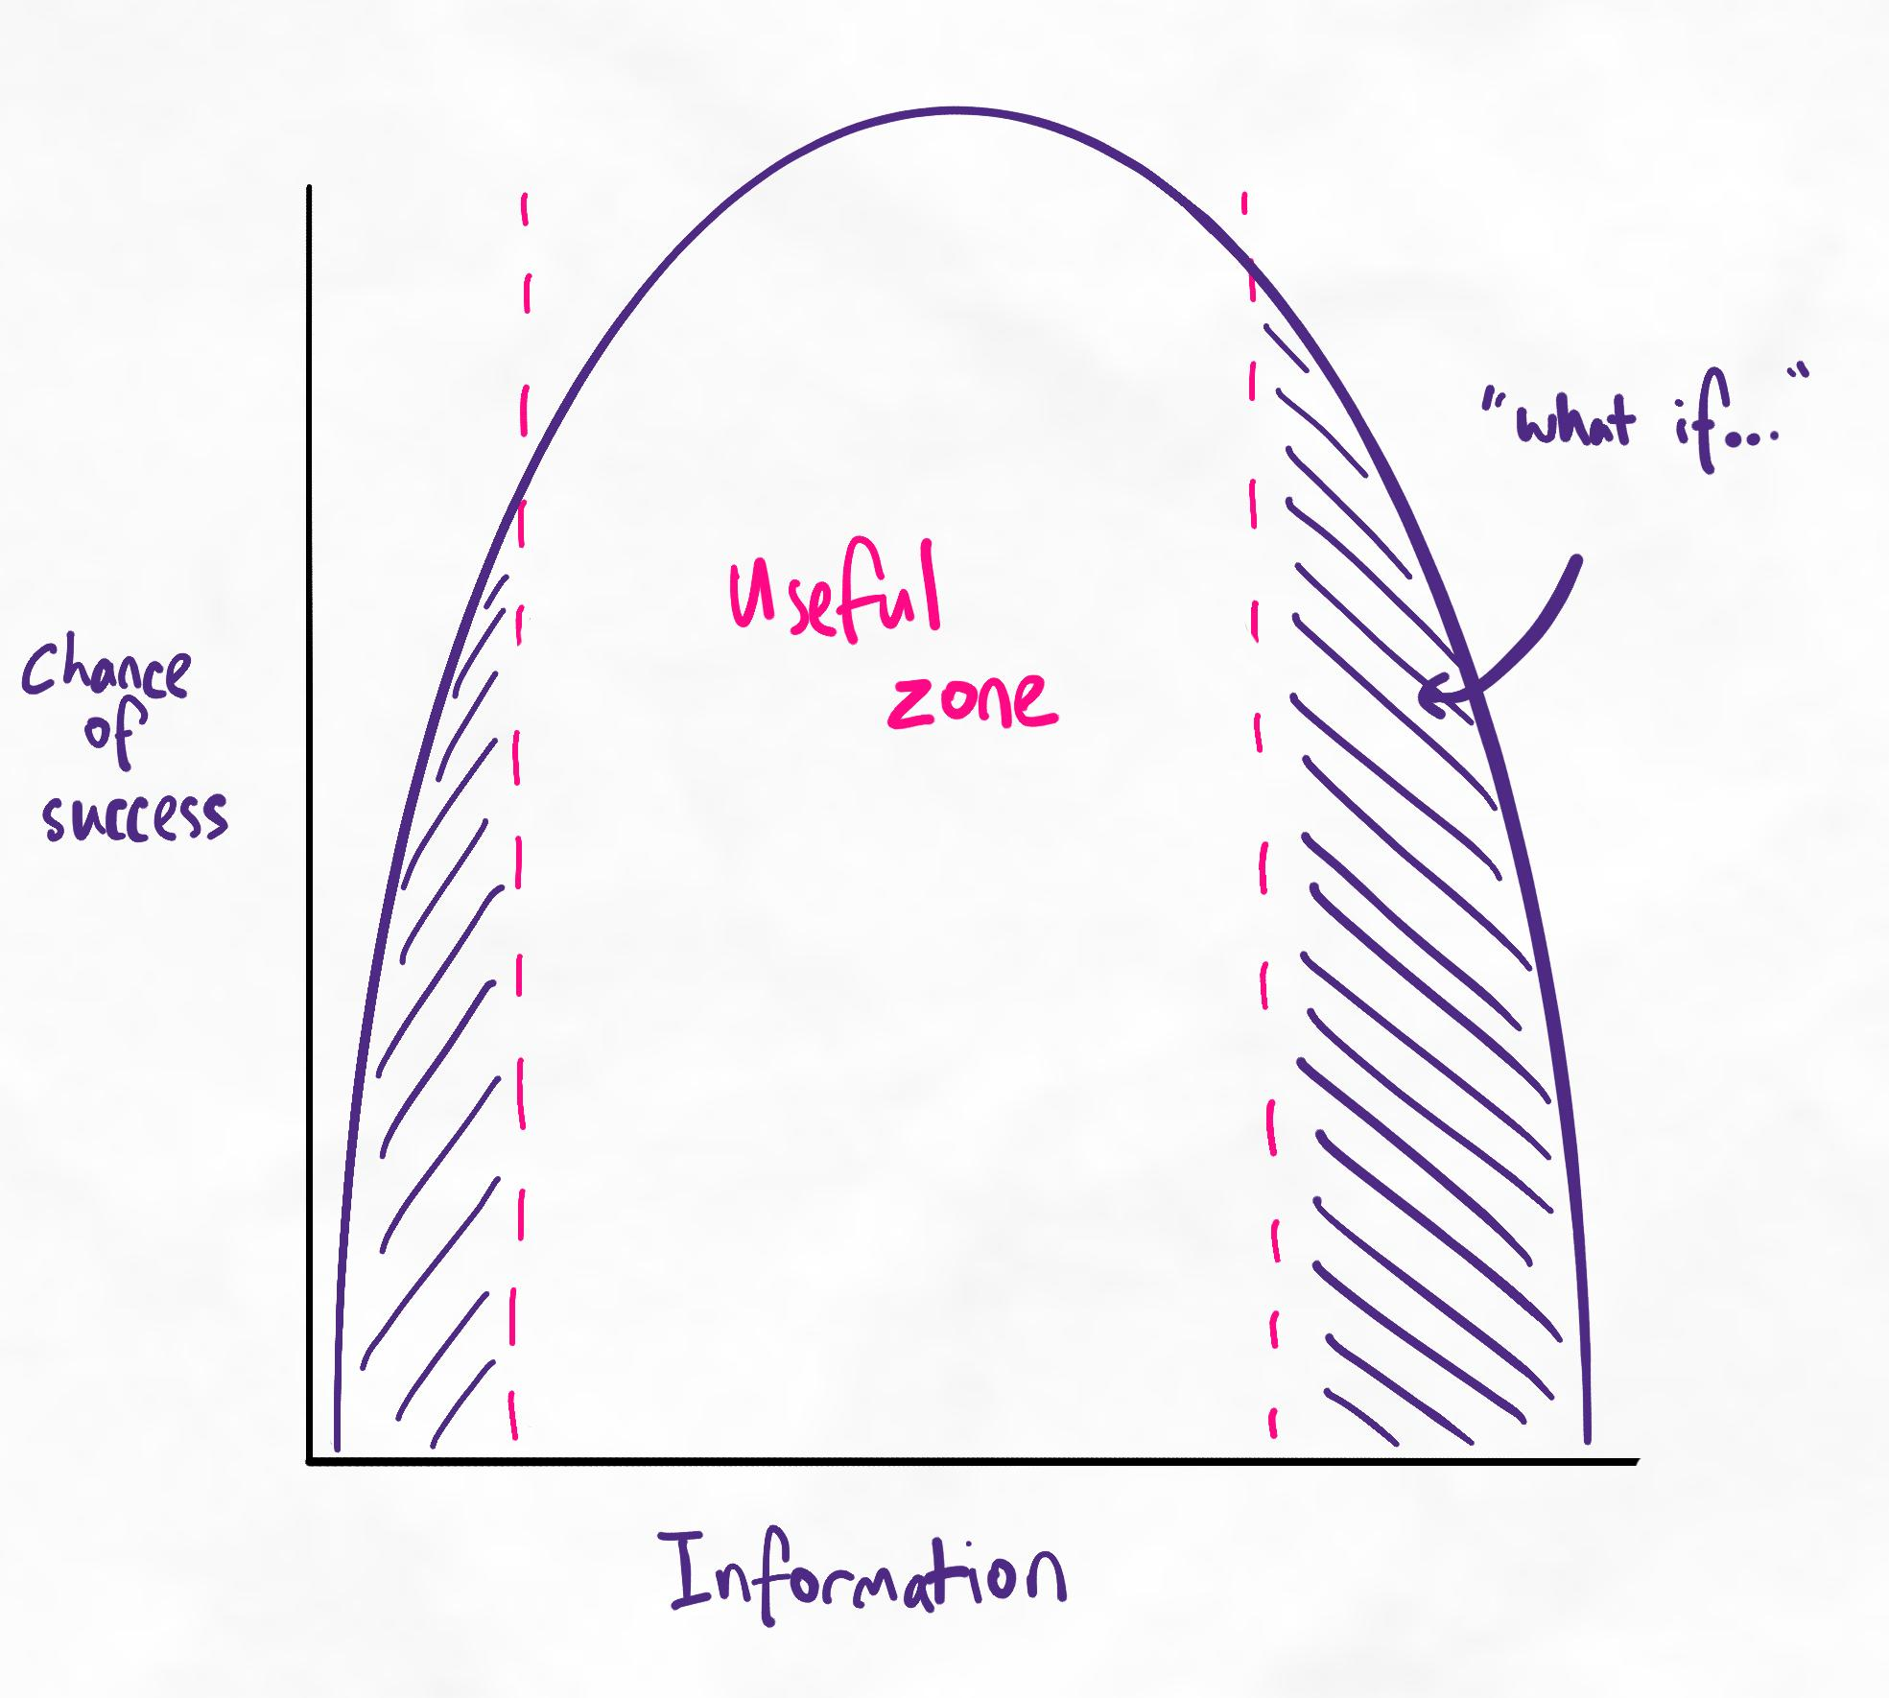The inverse-U relationship between information and chance of success.

The value of questions
Asking questions is an important part of learning.
- Questions about new methods are helpful when they help you gain clarity over the process.
- Questions that ask about "what if" scenarios to reduce the risk of mistakes that may never occur are not helpful.
How much information is enough?
The best time to make your first attempt and experiment is when you have:
- Enough information to attempt the method
- Enough information to know what doing it correctly looks and feels like
- Not enough information to do it correctly
The objective of the early attempts is to understand which mistakes you are most likely to make. This dramatically improves your learning and skill acquisition because questions are transformed into more effective forms, as described below.
The amount of information needed to have clarity and start experimenting is relatively low. The amount of information needed for certainty is usually very high. Often, the amount of information we need for total certainty exceeds what our brain can handle and what is even possible to know before experience and practice.
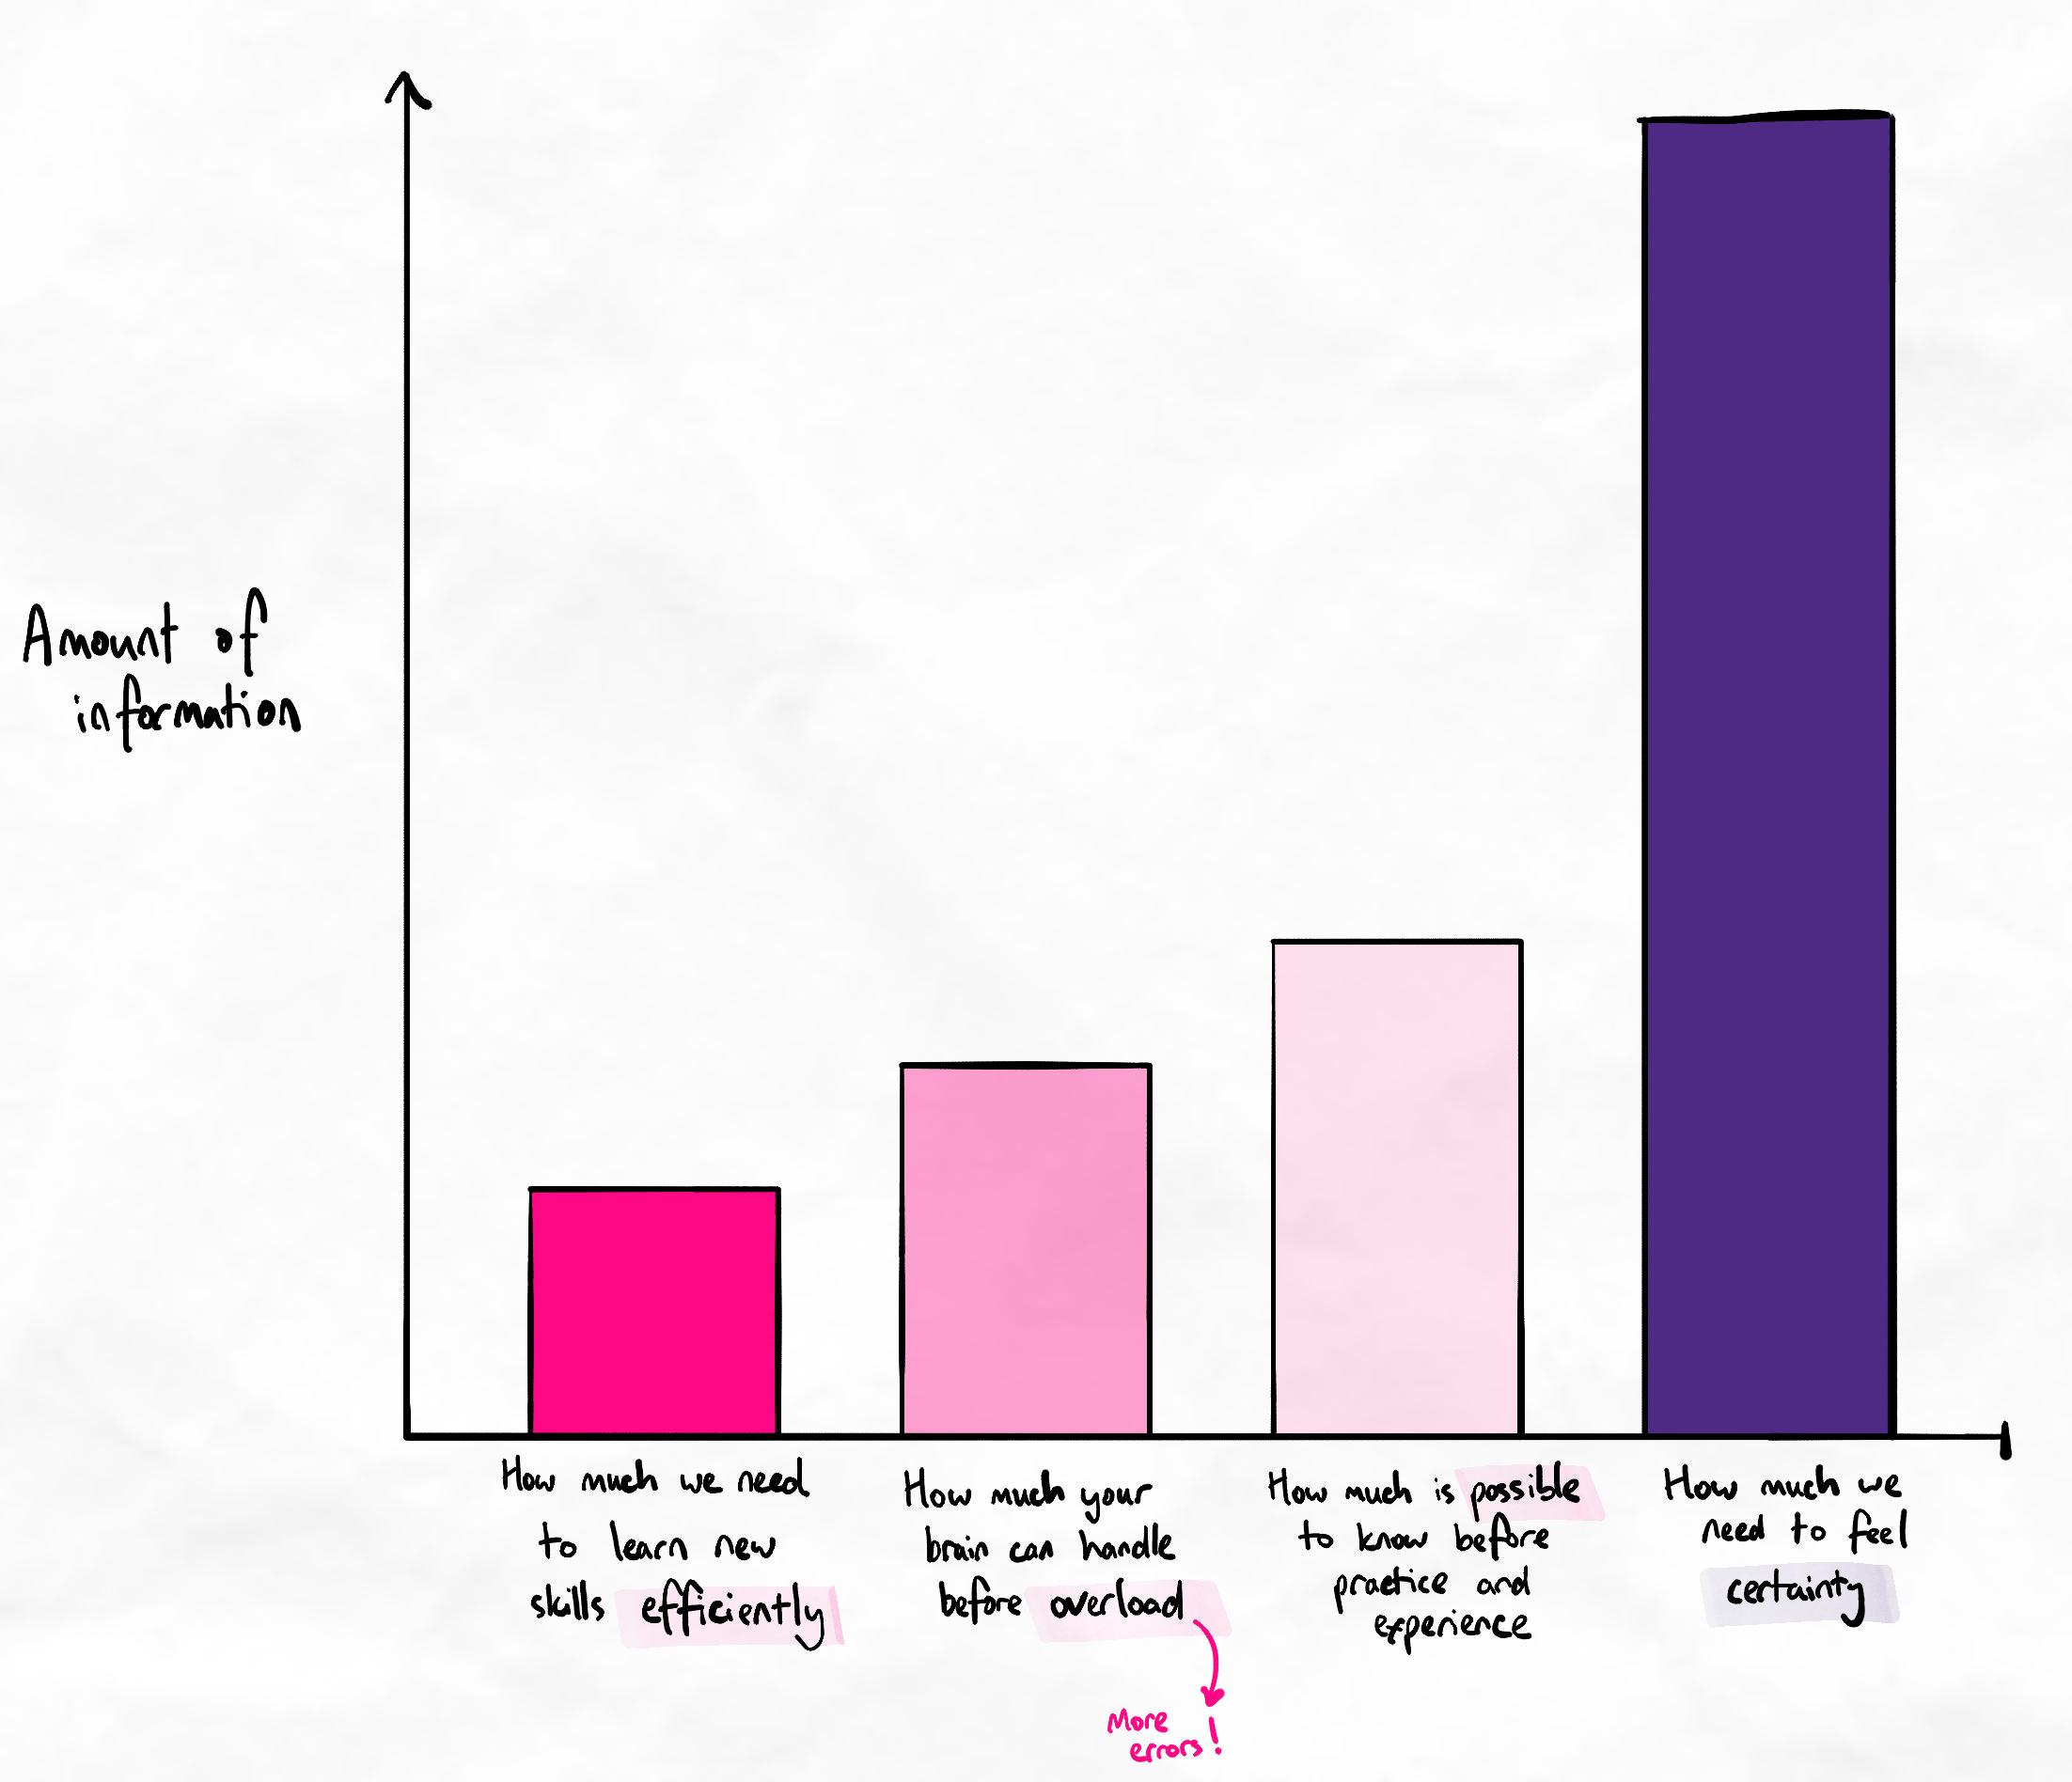The amount of information we need for certainty is unrealistic before practising.
Key principle
Asking the right questions at the right time significantly increases your ability to develop new skills.
Ineffective question
"What if I make this mistake?"
In response, you could ask, "What if you don't?"
These "what if..." questions have a low chance that this mistake will even be made. Time could be wasted on gaining clarity on a situation that is not relevant.
Effective question
"I tried this and found I made this mistake. How could I overcome it?"
This question is directly relevant as it is rooted in real experience.
Valuable questions to ask
Questions to ask | When to ask them | Notes
Questions that improve calibration. For example:  - How do I know if I have done this correctly?  - What does it feel like to do this correctly? | Before and during your attempts | These questions may not always be easy to answer. Again, some things can only be felt and known through experience.
Questions that help you avoid unnecessary risks. For example:  - Are there any common mistakes I should be aware of when using this method?  - Are there any situations where it is not appropriate to use this method? | Before and during attempts | Not every mistake needs to be made personally. Some mistakes are unnecessary as they do not aid in learning the skill. These can be avoided.  Notice how these questions are open-ended. They do not ask about specific hypotheticals. The answer could still be that you must find your mistakes through experience.
Questions that help with your experiments. For example:  - I tried the method and found these difficulties. I think the problem is [ABC] and, therefore, I think I should try [XYZ] next. What do you think? | After attempts | Notice the structure:  - What I did  - What I found  - What I think is the issue  - What I propose as an experiment

